Analyzing Airline Networks for CO2 Emission Reduction
Afua Frempong¹[90434176]
¹ University of British Columbia, Kelowna BC, Canada
Link to Github Repo: https://github.com/abstractafua/co2nnections
Abstract.
This project investigates the structure and efficiency of global and Canadian airline networks with a focus on CO₂ emissions. Using network analysis techniques, I assessed air connectivity worldwide and identified central Canadian airports through degree, betweenness, and closeness centrality. I calculated distances and estimated emissions for Canadian routes, then applied community detection to highlight clusters with high emissions. The findings reveal key airports and routes that contribute most to overall emissions, informing potential targeted interventions. The project concludes with recommendations for optimizing Canadian airline travel to reduce CO₂ emissions, such as prioritizing high-emission communities and central airports for route restructuring and efficiency improvements.

Keywords: Airplane, Jet Fuel Emissions, Air Travel.
- Introduction
  - Deviation from Proposal

Because route data for private airlines is not easily accessible or readily available, I had to pivot my project topic to deliver a more expansive and rounded analysis and solution proposal. Some of the main drawbacks I ran into with my initial data source celebrity private jet tracker.com was the amount of cleaning I had to do in order to get the data, the few nodes (I was provided with only 60-62 nodes) and the lack of route destination and source information.

Overview

However, I took this opportunity to still conduct analysis on Air travel from the standpoint of efficiency and emissions. I am panning out and expanding the scope of my project in order to get more data and see more trends within air travel routes and C02 emissions. In this project I will investigate the structure and efficiency of global and Canadian airline networks with a focus on CO₂ emissions.

Sample Heading (Forth Level). The contribution should contain no more than four levels of headings. The following Table 1 gives a summary of all heading levels.

Table 1. Airport.data schema
Table 2. Routes.data schema

- Methodology

This project employs a quantitative network analysis approach to investigate airline connectivity and CO₂ emissions, with a focus on Canadian air travel. The research design consists of three main phases: data collection and cleaning, network construction and analysis, and emissions estimation.

  - Data Collection and Cleaning

I constructed a directed network representing global airline routes using the OpenFlights “airports.dat” and “routes.dat” datasets. The airports file was first loaded and cleaned by removing entries with missing IATA codes, as these values are necessary for matching route endpoints. The routes file was then filtered to remove any rows where the source airport, destination airport, or airline identifier contained missing values. Because the route file contains a mix of IATA and ICAO codes, I retained only those routes where both the source and destination airports matched valid IATA codes in the cleaned airport list. This ensured that the resulting graph only contained real airport-to-airport connections.

  - Network Construction & Analysis

Using the cleaned data, airline networks were modeled as graphs with airports as nodes and routes as edges. The igraph package in R was used to construct both directed and undirected graphs. Key network metrics such as node count, edge count, and average degree were calculated to assess overall connectivity. For the Canadian subnetwork, centrality measures such as degree, betweenness, and closeness were computed to identify the most influential airports. The community detection algorithm (Louvain method) was applied to uncover any interconnected airports.
  - Emissions & Estimations

To estimate CO₂ emissions, the great-circle distance between airport pairs was calculated using the geosphere package’s distHaversine function. An emission factor (kg CO₂ per passenger-kilometer) was applied to these distances to estimate emissions for each route. Routes were then ranked by total emissions to identify high-impact connections. Visualization techniques included network plots and bar plots for centrality measures.
Given :
3.5 L jet fuel / 100 passenger-km which means 0.0035L of fuel per passenger-km
Taken from https://www.ipcc-nggip.iges.or.jp/public/2006gl/pdf/2_Volume2/V2_3_Ch3_Mobile_Combustion.pdf [1].

- Results
  - What is the average degree of the worldwide airline directed network, and what does this base start to reveal about global air connectivity?
The final directed network consisted of 6072 airports and 66475 flight routes after cleaning and filtering. When computing degree values across all nodes, the average in-degree was 10.94779, and the average out-degree was 10.94779. These averages indicate that most airports connect to only a relatively small number of other airports in terms of both incoming and outgoing flights. The values are the same naturally because in-degree = out-degree in a directed network.

The network visualization produced using the Fruchterman–Reingold layout further illustrated highly connected airports were positioned near the center of the graph, while lower-degree airports were pushed to the periphery.

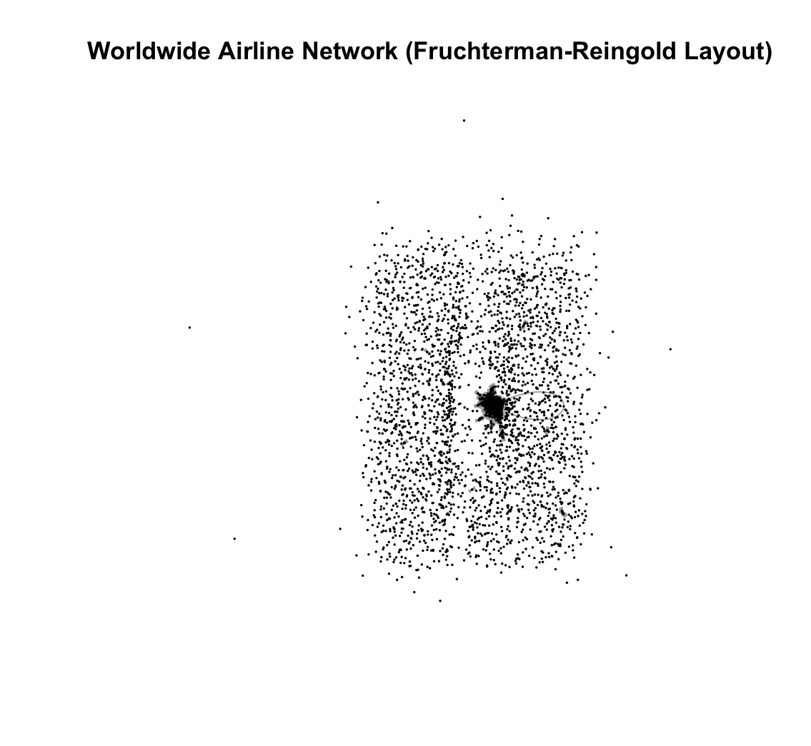

The histograms of the degree distributions showed a strong right-skewed pattern for both in-degree and out-degree, confirming that the network follows a hub-and-spoke structure rather than a uniformly distributed system. This revealed an uneven distribution of connectivity. A small number of airports displayed very high in-degree and out-degree values, while the majority had far fewer connections. The top ten airports by in-degree and out-degree included major international hubs with extensive route networks, confirming their role as the primary gateways for global air travel.

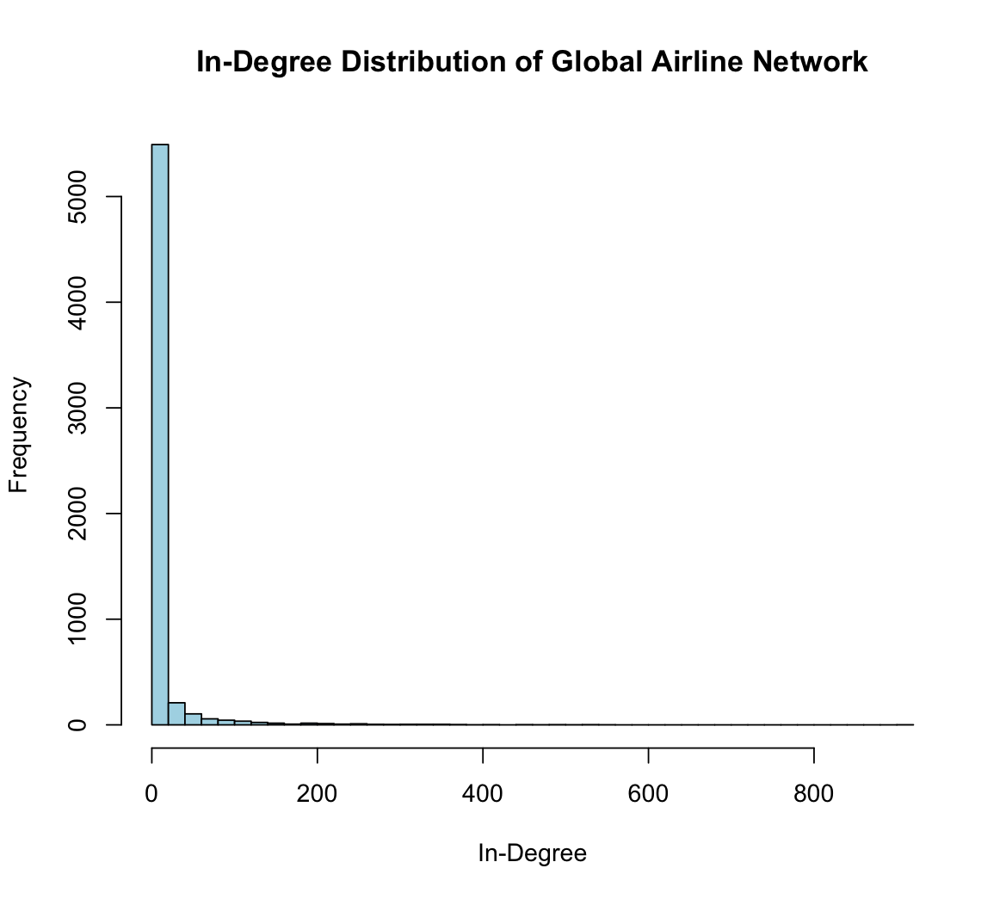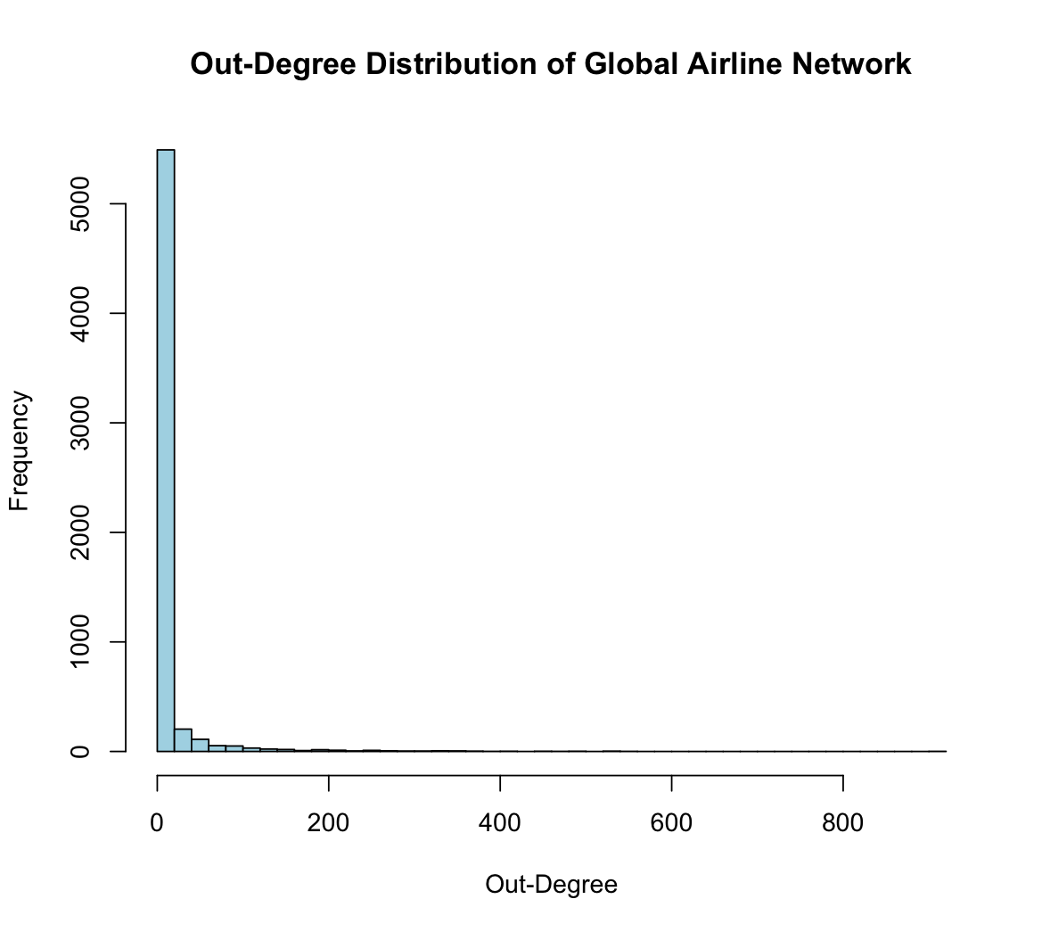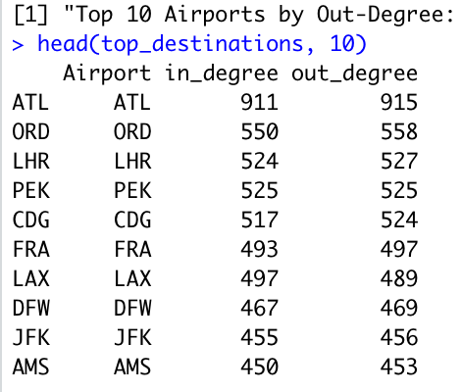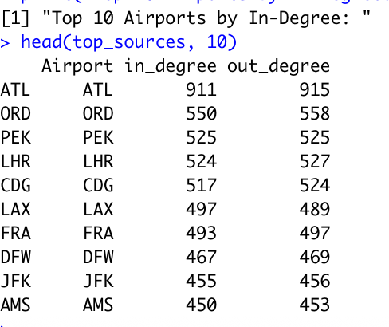

Overall, these results suggest that global air connectivity is unevenly distributed, with a small number of highly connected hub airports serving as key nodes in the worldwide transportation system. This structure plays an important role in determining efficiency, load distribution, and network vulnerability in global air travel.

  - Which Canadian airports are the most central according to degree, betweenness, and closeness centrality?
The Canadian airline network analysis revealed distinct patterns across the three centrality measures. The top 5 airports by degree centrality were primarily major metropolitan hubs, indicating airports with the highest number of direct connections.

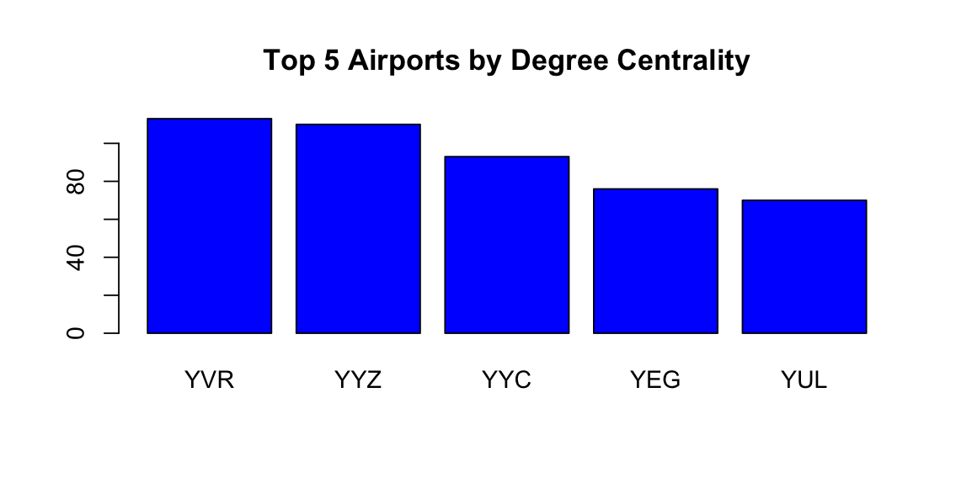

Betweenness centrality identified airports that serve as critical intermediaries in the network, connecting different regions of Canada. Closeness centrality highlighted airports that can reach all other Canadian airports.
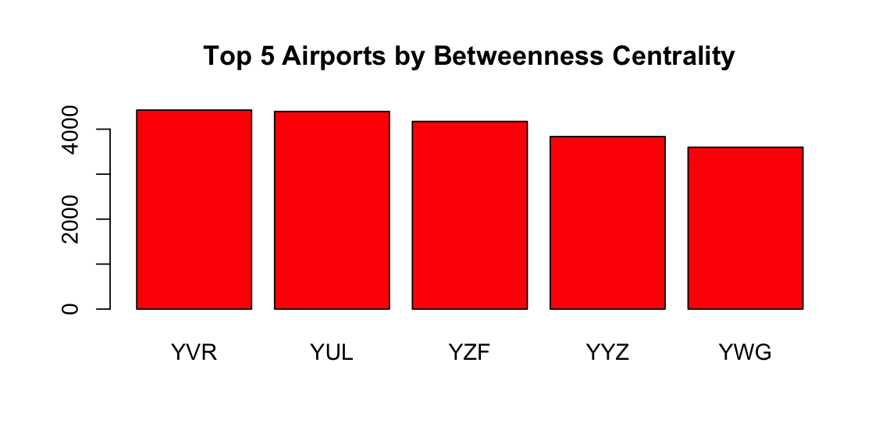

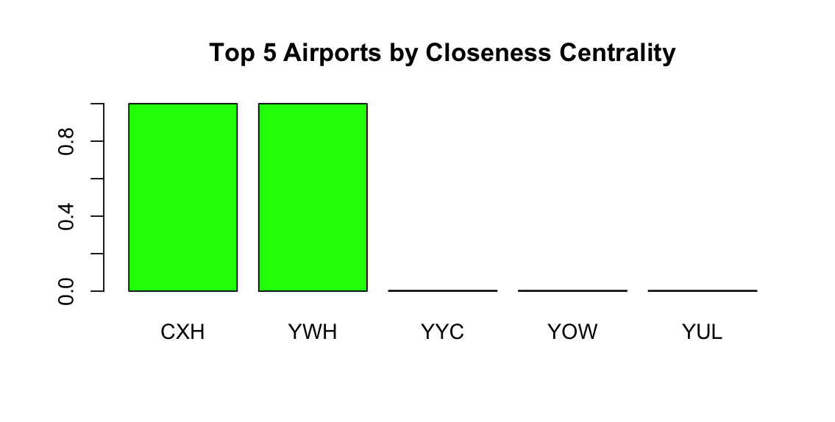

The bar plot visualizations showed that certain airports such as YVR and YUL consistently ranked high across multiple centrality measures, suggesting their critical importance to Canadian air connectivity.

  - How is distance and emission distributed for Canadian routes?
Using the Haversine formula to calculate great-circle distances between Canadian airport pairs, the analysis revealed variation in route lengths. The longest routes connected airports across the vast Canadian geography, particularly transcontinental routes linking the Prairies, Atlantic to and from Pacific regions. Distance calculations were converted to kilometers and stored in the canadian_routes_with_distances data frame.

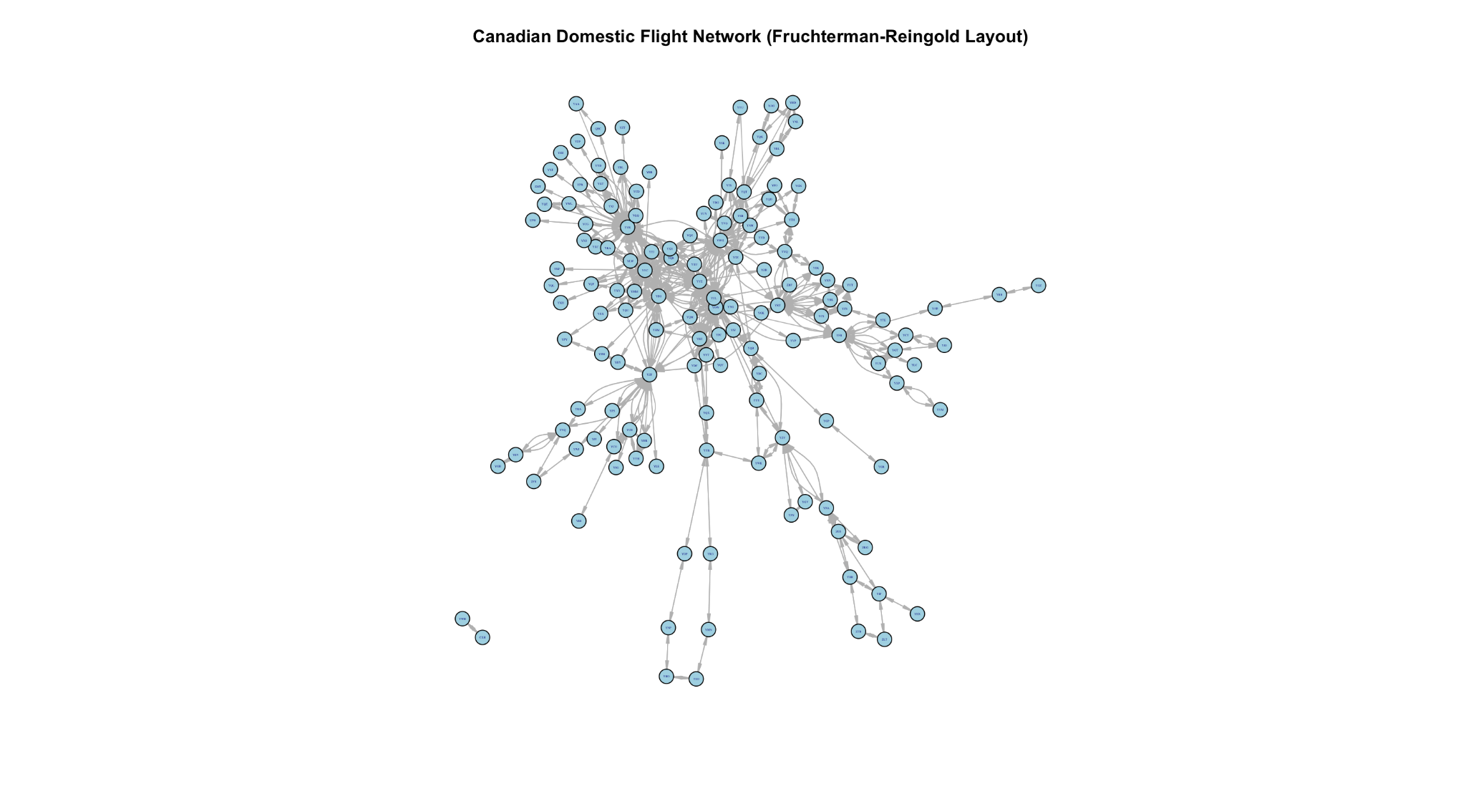


  - How can Canadian airline routes be optimized to reduce CO₂ emissions, and which routes should be prioritized for intervention?
The emissions analysis using a jet fuel emission factor of 0.035 kg per passenger-kilometer revealed substantial variation in environmental impact across Canadian routes. The jet fuel emission calculations identified the highest-impact routes.

Community detection using the Louvain algorithm revealed clusters of airports with high internal connectivity. The top 10 highest-emission routes were predominantly long-haul flights connecting major cities across provinces.

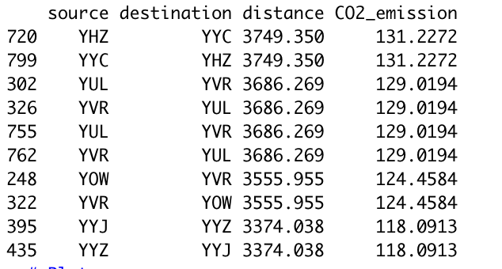

The analysis suggests that emission reduction strategies should focus on: (1) optimizing fuel efficiency on high-emission transcontinental routes, (2) consider alternative fuels or more efficient aircraft for these connections, and (3) potentially restructuring route networks within high-emission communities to reduce total distance traveled. The combination of centrality analysis and emissions data provides a framework for prioritizing interventions at airports that are both highly central and involved in high-emission routes.

- Discussion
  - Summary of Findings
This network analysis of global and Canadian airline connectivity revealed several key insights about air travel structure and emissions patterns. The worldwide airline network demonstrated a classic hub-and-spoke architecture, with average degree values indicating that most airports maintain connections to only a small subset of global destinations.

The highly skewed degree distributions confirmed that a small number of major international hubs dominate global connectivity, serving as critical gateways for international air travel. These hubs are located in Atlanta, Chicago, Beijing, London, Paris, Los Angelos, Frankfurt

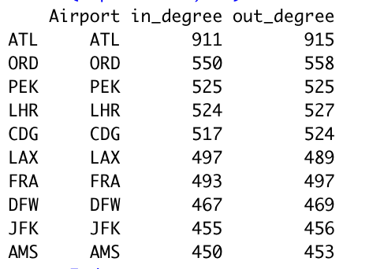

Within the Canadian context, centrality analysis identified key airports that serve distinct roles in the domestic network. Airports with high degree centrality represent major connection points with numerous direct routes, while those with high betweenness centrality function as critical intermediaries connecting different regions of Canada.
These key airports being in Toronto, Vancouver, Calgary, Edmonton and Montreal.

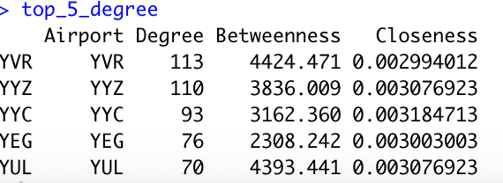

  - Implications of Findings
These results have implications for sustainable aviation policy and route optimization. For Canadian aviation specifically, the identification of high-emission routes and central airports provides a roadmap for prioritizing sustainability initiatives.

  - Limitations
Several limitations should be acknowledged in this analysis. The OpenFlights dataset, while comprehensive, may not capture all operational routes or reflect current flights, which can significantly impact actual emissions. Additionally, the analysis focused on direct flight distances without considering actual flight paths, which may deviate due to air traffic control, weather, or other operational factors. Furthermore, one of the drawbacks is that route data was not up to date (i.e some routes could have been created or removed since). This analysis can still optimize a later model representation of global air routes.

  - Future Directions
Future research should incorporate more granular data including flight frequencies, passenger loads, and aircraft-specific emission factors to provide more accurate environmental impact assessments.

Integration of economic factors, such as route profitability and operational costs, would provide a more comprehensive analysis for evaluating necessary intervention. Additionally, expanding the analysis to include other transportation options (rail, bus) could identify opportunities for shorter routes where alternative transportation might be more sustainable.

- Conclusion
This network analysis of global and Canadian airline connectivity provides insights into the structure of air travel networks and their environmental implications. The study demonstrated that global airline networks follow concentrated connectivity at major international airports, while Canadian domestic routes exhibit similar patterns of centralization around key metropolitan hubs.

The identification of high-emission routes and central airports through network analysis and distance calculations offers a data-driven approach to prioritizing sustainability interventions in Canadian aviation. By combining centrality measures with emissions estimations, this research could provide a framework to guide policy decisions toward more environmentally sustainable air travel.

References
- IPCC. (2006). 2006 IPCC Guidelines for National Greenhouse Gas Inventories: Volume 2 – Energy, Chapter 3: Mobile Combustion. Intergovernmental Panel on Climate Change.

